**How to change your password in ARCH-Commons:**

Once you have an account set up for the webclient, then navigate to the following link and sign in using the credentials sent to you regarding your account activation:

<http://search.arch-commons.org/webclient/>

Click the ‘Yes I agree’ button to agree to not identify individual patients, and then you will be directed to the page as seen below.

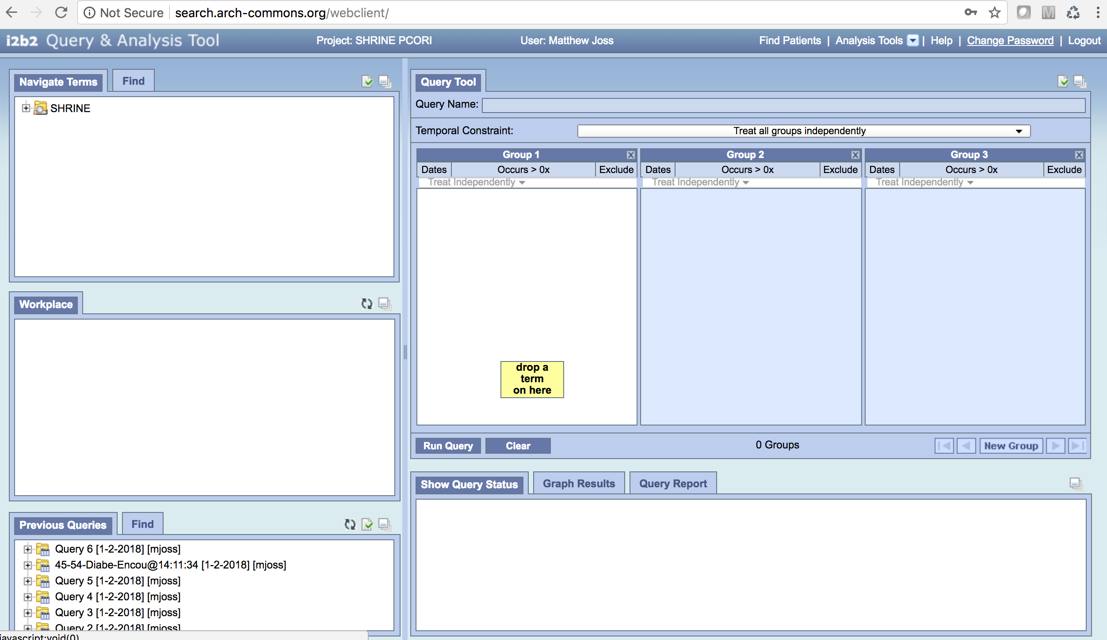

Click on the ‘Change Password’ link in the upper right hand corner of the window. This will open a pop-up window as seen below.

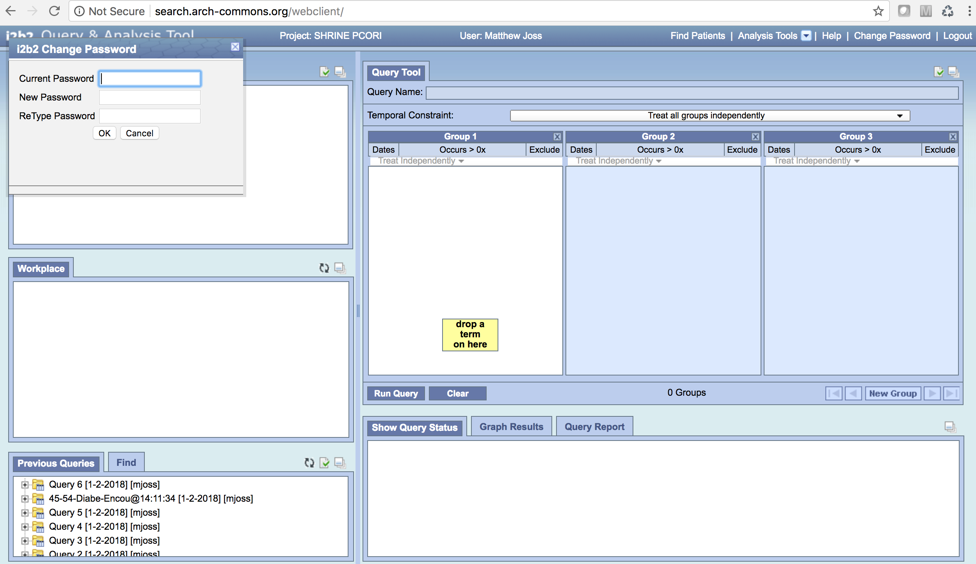

Enter your current password, and then enter and re-enter your new password. Make sure to hit the ‘OK’ button when you are finished to save the new password.

You are done! Now you can go to the actual webclient and sign in with your new password:

<https://search.arch-commons.org/shrine-webclient1224/>